California Native Grasslands Association: Learning About California Grasslands
Lesson Title: What Was Here Before?
Grade level: Early-mid elementary
Lesson Length: 45-60 minutes for video and worksheet completion
Preparation and Materials: CNGA “What was here before?” video, pencils
Lesson Goal: Students learn about California grassland habitats, the species that live in them, and why they are important to wildlife as well as humans.
Lesson Description: Teacher plays and guides students through the video, helping with reading, defining vocabulary and going over key concepts. Students complete worksheet by answering questions and drawing pictures.
Lesson Objectives: Students interpret information from a video lesson to answer questions and draw conclusions.
Lesson Background:
Grasslands are defined as habitats made up of low growing plants (mainly grasses and forbs with few trees or shrubs. In California, grasslands are an important ecosystem and cover almost 20% of the state. There are many types of grasslands in California, ranging from coastal prairies to working rangelands to alpine meadows. California grasslands were historically composed of native perennial bunchgrasses interspersed with a highly diverse flora of other plants. However, modern day grasslands usually contain many species of exotic annual grasses and weeds introduced from other areas. Grasslands are important habitat for animals such as birds, insects, amphibians, reptiles, and mammals, including many rare and endangered species. Grasslands are also used by humans to graze livestock which produce meat, milk, and clothing materials. In addition, grasslands provide ecosystem services such as filtering and storing water from precipitation, sequestering carbon, and preventing soil erosion.
Selected Vocabulary Words:
Burrow - (n.) a hole or tunnel in the ground dug by an animal to use as a dwelling. (v.) the act of digging such a hole or tunnel
Grass - type of plant that is low-growing with long, narrow leaves and usually hollow stems
Grassland - an open field of low-growing plants
Forb - a broad-leafed herb
Rushes and sedges - grass-like plants that grow in wet or marshy areas
Raptors - birds that hunt and feed on other animals

“What was here before?” Worksheet Name:_______________________________

- What is a grassland?

- Name 2 kinds of plants that grow in California grasslands

- Draw and color the following:
A wildflower (forb) | A bunchgrass

- Name a large mammal that lives in California grasslands

- Draw and color a type of animal that lives in the grassland

What type of animal is this? ________________________________

- Name a type of a bird that lives in California grasslands

- Name a type of animal that lives in burrows underground. Do all animals make their own burrows?

- Critical thinking
How do the animals below use grasslands? What do humans get from these animals?
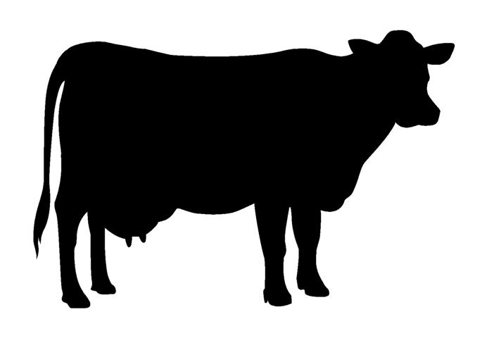

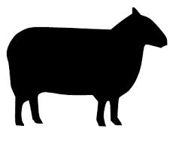

- What will YOU say if someone asks you “what was here before?”
Why are grasslands important to us?

“What was here before?” Worksheet – TEACHER’S KEY

- What is a grassland?
A grassland is an open field of low-growing plants.

- Name 2 kinds of plants that grow in California grasslands
Forbs (wildflowers), grasses, sedges/rushes
Specific examples: Yampah, lilly, clover, poppies, purple needlegrass, California brome, or Idaho fescue

- Draw and color the following:
A wildflower (forb) | A bunchgrass

- Name a large mammal that lives in California grasslands
Deer, tule elk

- Draw and color a type of animal that lives in the grassland

What type of animal is this? ________________________________
Examples: Insects (butterflies, beetles, bees), deer, birds, snakes, toads, salamanders, voles, squirrels

- Name a type of a bird that lives in California grasslands
Western meadowlark, savannah sparrow, horned lark, grasshopper sparrow, mourning dove, chestnut-collared sparrow, northern harrier
- Name a type of animal that lives in burrows underground. Do all animals make their own burrows?
Examples: Ground squirrels, kangaroo rats, badgers, tarantulas, toads, salamanders, burrowing owls, gopher snakes, weasels. Not all animals make their own burrows, many use burrows created by other animals.
- Critical thinking
How do the animals below use grasslands? What do humans get from these animals?
  - Cows graze on grassland plants, we get milk, meat, and leather from them.

  - Sheep also graze on grassland plants, we get wool, meat, and milk from them.

- What will YOU say if someone asks you “what was here before?”
Why are grasslands important to us?

